# Configuration of Windows Subsystem for Linux WSL

1. Go to **Programs and Features**, select **Turn Windows features on or off**.

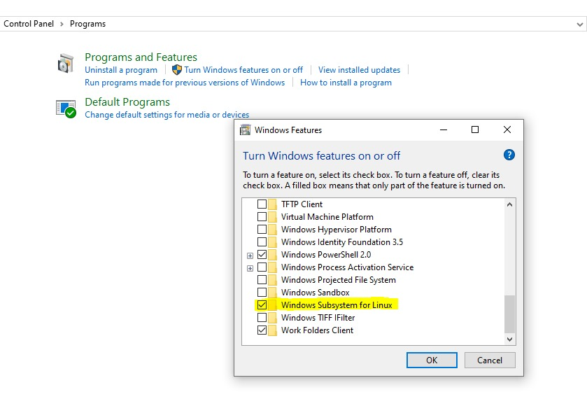

1. Restart the computer after enabling **Windows Subsystem for Linux.**
2. After restart, Go to **Windows Store** and Search for Ubuntu and install  
   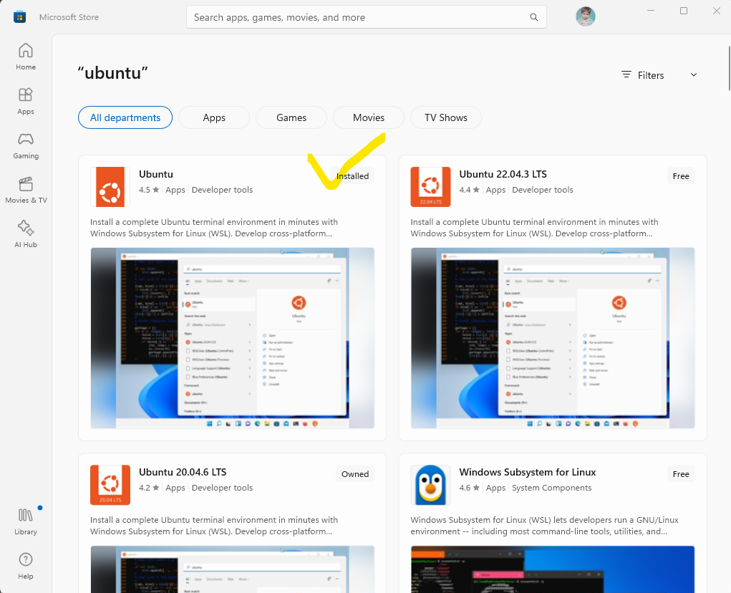
3. Set Username and Password and your Ubuntu will be installed.
4. Open Linux Shell by pressing shift and right click of the mouse.



